Year 7 – Investigation
/34

Do rubber Bands obey Hooke’s Law

HOOKE”S LAW
It is a law of mechanics and physics by Robert Hooke. This theory of elasticity says the extension of a spring is proportional to the load applied to it. Many materials obey this law as long as the load does not exceed the material's elastic limit.
The spring equation
The length of a spring always changes by the same amount (EXTENSION) when it is pushed or pulled by the same amount of FORCE . The equation for Hooke’s law is:
F = k x E
where
F is how much Force (push or pull) is on the spring. The force must be measured in Newtons
k is a constant, the stiffness of the spring. The units for this are $\frac{Newton}{metres} or N/m$.
E is how far the spring was pushed or pulled. This must be measured in metres

When the spring is not extended, E = 0 which means the spring is not being pulled by a force (in the equation above, if E is zero, then the answer for F must also be zero). As the force increases the extension increases by exactly the same proportion. What this means is that if you double the force applied to the spring, the extension of the spring would double. Force and extension are said to be directly proportional to each other. Therefore a graph of force versus Extension was made, the data should form a straight line, and the slope of the line would be equal to the spring constant.
Hooke’s law equation holds true for most metal springs. However other objects can also store elastic potential energy. Rubber bands are often used in a similar way to metal springs as they are much cheaper to make. But do rubber bands abbey Hooke’s las as well as metal springs do? To investigate this, a rubber band will have force applied to it and the extension of the rubber band measured. The force will be varied a number of times and the extension measured. These values will be graphed on a scatter graph. If rubber bands obey Hooke’s law then the dta will form a straight line, and the slope of the line will indicate the spring constant of the rubber band. A thicker rubber band should have a higher spring constant than a thin rubber band.

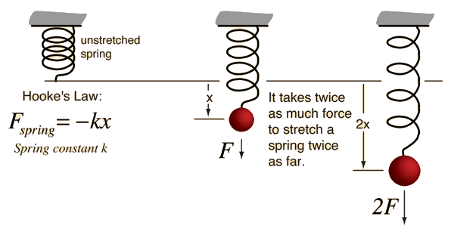
METHODOLOGY – perform this experiment in a very similar manner to the original Hooke’s law experiment, but using a rubber band rather than a spring. You will have to make decisions about how much force (weight) to use. The results you obtain may or may not be the same – it will depend on whether rubber bands obey Hooke’s Law.

Hooke’s Law: Elastic Band Practical
Aim
To find the relationship between the force exerted on an elastic band and the extension of the elastic band and in doing so identify if rubber bands obey Hooke’s Law.
Prediction (What do I think the relationship between the Force (weight) and the extension will be?):
_______________________________________________________________________________________
_______________________________________________________________________________________
(2 marks)

Results

Table 1: Thick rubber band
Before masses are added to the spring: Height (m) = ______________________
Mass  (g) | Mass (kg) | Force (N) | Height 1 (m) | Height 2 (m) | Average Height (m) | Extension (m) | Force  Extension  (N/m)
(5 marks)

Table 2: Thin rubber band
Before masses are added to the spring: Height (m) = ______________________
Mass  (g) | Mass (kg) | Force (N) | Height 1 (m) | Height 2 (m) | Average Height (m) | Extension (m) | Force  Extension  (N/m)
(5 marks)
Note:
- To convert from g to kg, divide the mass in grams by 1000
- To convert from cm to m, divide the height in cm by 100
- To calculate the force exerted by the mass hanger: Force (N) = mass (kg) X 10
- Ensure that your average height has the same number of decimal places as each of the heights measured
- To calculate the extension, subtract the average height from the starting height

Graph: Plot the graph with Force (Y-axis) against extension (X-axis) and draw a line of best fit. Draw one line for the thick rubber band abnd a second line for the thin rubber band.
Note: For this graph we will plot the independent variable on the Y-axis and the dependent variable on the X-axis.

(6 marks)
Analysis
Part A
Describe the pattern you see for the thick rubber band. You should start by stating if the rubber band obeyed Hooke’s law (as this is the main point of the experiment). You should then explain why you think this by referring to the data on the graph or in the table. Hint – do the data points for a straight line?

(4 marks)

Part B
Describe the pattern you see for the thin rubber band. You should start by stating if the rubber band obeyed Hooke’s law (as this is the main point of the experiment). You should then explain why you think this by referring to the data on the graph or in the table. Hint – do the data points for a straight line?

(4 marks)

Part C Describe the amount of error you believe was in the experiment. You should start by stating the amount of error you think in in the experiment. You should then elaborate with more detail – were there particular parts which contained error, was it just one or two data points. You should refer to specific data points on the graph or the table

(4 marks)

Part D Explain what created the amount of error you mentioned in Part C. There may be several errors you think were made. Explain what one error was and explain how it caused your data points to be inaccurate. Then repeat for each source of error you think of. Try to be specific about how the error affected your results.

(4 marks)

